NYU-Poly
Firefighting Boe-Bot
Mechatronics Integrated Final Report
Carlos Fernandez, David Lopez, Andre Roman

Contents
Introduction 2
Mechanical Design 2
Electrical Design 3
Software Design 7
Cost Analysis 10
Safety Operation 11
Possible Design Improvements 11
Conclusion 12
References 13
Code 14

Introduction
During fires in relatively large building, dousing the structure through windows and roof openings allows for control of the fire but remaining fires within the building may last. This requires firefighters to enter said structure, which may have become structurally unstable, in search of surviving fires which may endanger the firefighter due to lack of visibility and breathable air.
Removal of the human factor in task where the user may experience non-necessary danger has led to introduction of remote controller vehicles. These devices are capable of doing as the human user desires through a series of interactions between machine and user. The possibility for these robots to be controlled remotely allows the user to have eyes and ears in the field without the need to physically endangering him/herself. Firefighting has become a curious field where robotics is being applied, to the point where competitions are held for handheld robots to extinguish randomly positioned fires [1], as well as companies approaching the concept as an untapped robotic market [2].
The proposed robot design allows for sensing and dousing of small fires through manual means. The robot will be able to sense a fire from any position within its working range allowing for manual control of the robot by the user, who in turn is able to ‘interact’ with the environment as necessary while having constant feedback without the need of a computer screen.

Mechanical Design
The mechanical design of the system calls for a light and small system which will allow for ease in mobility. The proposed design incorporates components which are relatively simple to assemble while also being readily available.
Chassis
The working platform of the design will be the Boe-Bot provided by Parallax Inc (Fig. 1). Due to its simplicity in assembly and being readily available it will provide a sustainable chassis for the proposed system.
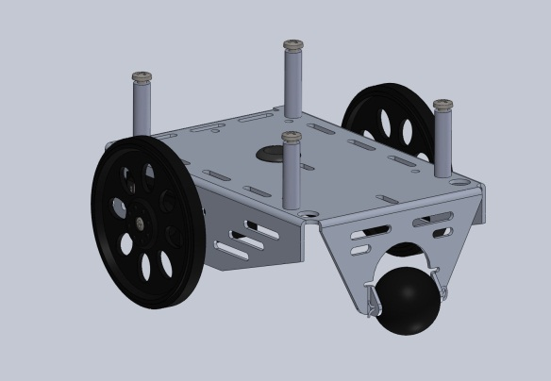
Figure 1 - Boe-Bot Platform
The chassis provided in the kit from Parallax Inc. is made from aluminum. It is specifically design to hold two continuous servos, which serve as the actuators for movement of the robot. The back wheel is a free moving rubber ball. The pegs seen in the figure, are mounted on the chassis, provide support for the Parallax Board of Education, which contains the Basic stamp 2 microcontroller.
Water Tank
The water tank is constructed from Plexiglas box of dimensions 5” x 3.25” x 2”, sealed such as to avoid leaking of water into the electrical system. The tank is positioned over the electrical components due to the available supports provided by the Boe-Bot platform as well as the increased range of having the water being pumped from the highest position available, allowing for the robot to be farther from the fire.
Water Delivery
The water delivery is achieved using an Edmund Electronic miniature water pump placed inside the tank. The pumps working range being 1.5-3V allows for proper usage within the system. Water is sent through a tube whose free end is attached to a servomotor allowing for wider displacement of water by changing the angular position of the motor.
The following figure (Fig. 2) shows the assembly of the system water system incorporating the pump, servomotor and glass case as it’s placed in top of the Boe-Bot.
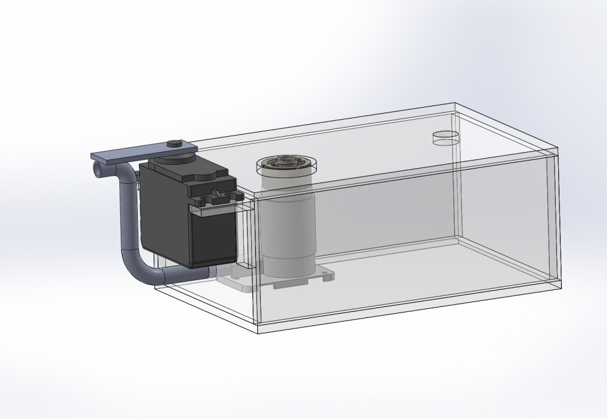
Figure 2 - Water Delivery System

Electrical Design
The electrical system proposed allows for proper interaction with the user through a tethered system. The user receives feedback from the system in the form of light signals through light emitting diodes (LEDs) to central hub from which the controller in connected. The overall system utilizes components available from the mechatronics class kit as well as extra components acquired to ease the interaction between the user and machine.
A general electrical schematic can be seen in Fig. 3.
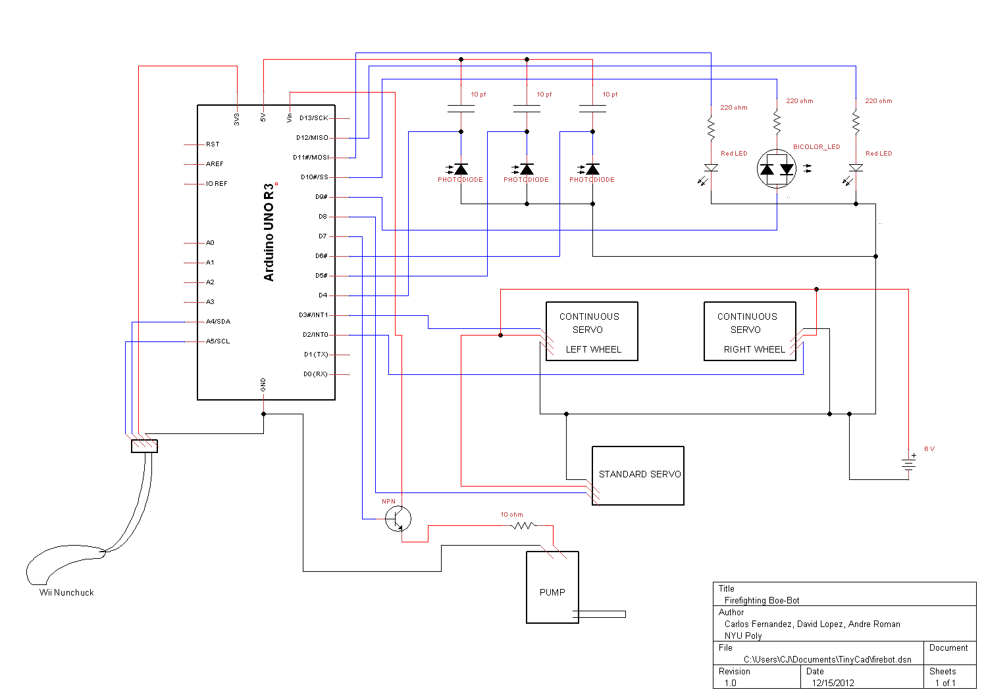
Figure 3 - Electrical Scheme

Microcontroller
The electrical system will be controlled by the Arduino UNO R3 microcontroller. The advantages of the Arduino microcontroller are its open source software, which allows for an extensive library for different interfaces. Due to certain equipment used, the Arduino is favored over the Basic Stamp 2 used during the class. The Arduino contains 14 digital I/O pins, which can provide 5 volts. Each pin can source/sink 40mA of current. Also, 6 of the pins have pulse width modulation (PWM). The Uno has 6 analog input pins, with 10 bit accuracy. These features provided by the Arduino platform were reasons why the Arduino was chosen over the Basic Stamp.
Wii Nunchuck
The human interaction component of the design will entail the use of the Wii Nunchuck. The Nunchuck uses a STMicroelectronics accelerometer to detect changes in position as well as the addition of a joystick and buttons for interaction.
The purpose of the Nunchuck in this design uses the accelerometer data to move the servomotor controlling the hose from the pump. The joystick allows for driving of the Boe-bot in any desired direction and a button is used as a trigger mechanism for the water pump.
Infrared LEDs
The electrical design of the system calls for the application of the duality of diodes as presented in class. A LED placed in reverse bias can act as a sensor to its expected output. For this project infrared LEDs will be used, which detect infrared light when a flame is present. The LEDs are placed in series with a capacitor such as to able to utilize the RCTime command to acquire a signal strength inversely relating to the distance from the source.
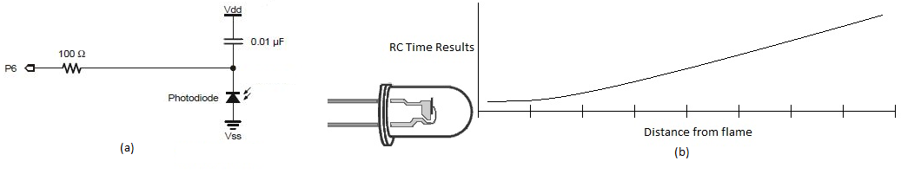
Figure 4 - (a) Photodiode in reverse bias, (b) Signal strength in relation to distance

Transistor
The PNP transistor utilized in this system allows for control of the water delivery system. Depending on the input supplied to the diode the pump will be activated or shut off. The following diagram graphically represents the above (Fig. 5).
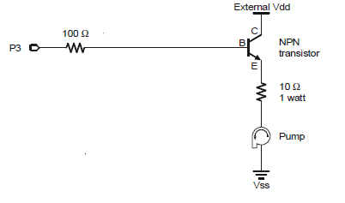
Figure 5 - Circuit diagram of pump and BJT
Servomotors
The Boe-Bot kit provides two continuous servomotors which are used to drive the vehicle as desired. An additional standard servomotor is used to position the hose as desired without the need to reposition the Boe-bot.

Indicators
Three LEDs will act as indicators to monitor the current status of the firefighting robot. The left and right LEDs are red, which will indicate that the fire is currently to the left or right of the boe-bot. The center LED is a bi-color LED (red/green), which will display red when the fire is sensed by the center infrared detector. Once the robot is in position, all three LEDs will be lit. When the fire is put out, green will be lit.
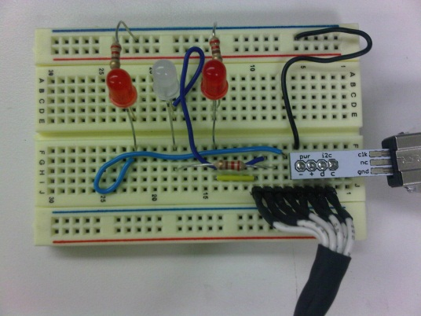
Figure 6: Indicators

Software Design
The software for the proposed project required a logic based system due to the implementation of several sensors to feedback into the user the relative position of the fire in relation to the front of the Boe-Bot. Note that the software accounts for proper allocation of signals into the following hub, where the controller is connected.
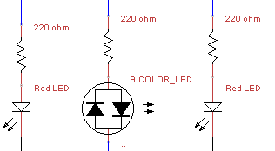
Figure 7 - Signal Plant for User Interaction
The following are excerpts of the code which are of interest. Initially it should be noted that there is lack of the RCTime function within the Arduino system as such the function is defined as follows (Fig. 7). The function set the pin as initially HIGH such as to allow for discharge of the capacitor into ground, after which the pin is set as input and defined LOW during which the results is continuously increasing until the pin physically LOW.
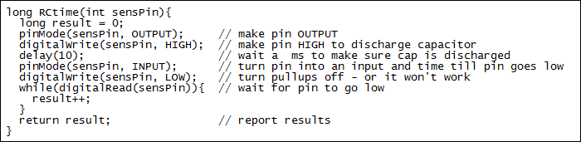
With the ability to acquire data relating to the fire the following code is a breakdown of the logic used to tell the user where the fire is, which is done by the flashing of LEDs in a respective manner (recall Fig.6)

The following is a snippet of code that we used to make the boe-bot autonomous. There were problems implementing autonomous control because the values of RCtime varied greatly with the amount of light the fire was emitting. Precision was not obtainable with the current setup.
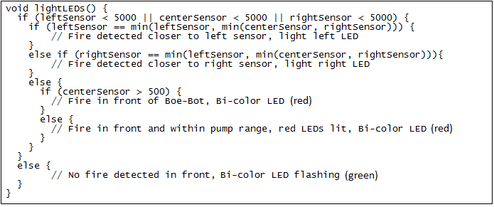

Accounting that the user know knows where the fire is s/he may properly react by using the Wii Nunchuck accordingly. The data is read and set as the right constants to denote direction of travel.
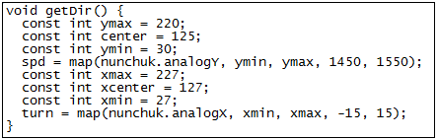

The microcontroller then applies the defined system constant for that instant into the respective tires, applying motion to the Boe-Bot.
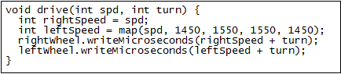

The following represents the main loop of the system in logical succession; sensors are checked, which feeds data to the user through LEDs, followed by the checking Nunchuck state, depending the state of the z-button turn pump on finally moving the Boe-Bot if required by Nunchuck input by defining turning and speed then applying to servos.

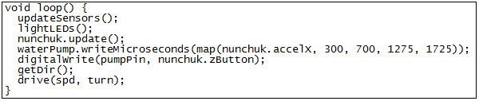
Complete code is available at the end of the report.
Final Prototype
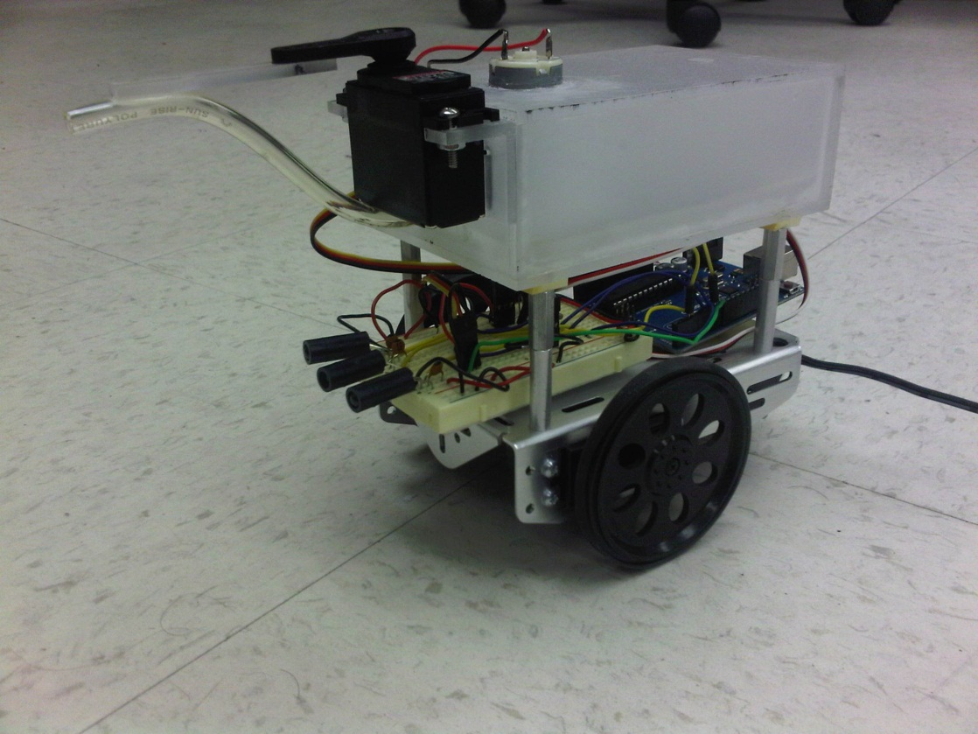
Figure 8: Prototype

Cost Analysis
Table 1 - Parts Cost
Item | Description | Vendor | Part No. | Quantity | Price per | Prototype | Production
1 | Boe-Bot Robot Kit | Parallax Inc. | 28132 | 1 | $81.99 | $81.99 | $65.59
 | 1/16" cotter pin |  | 700-00023
 | 1" tail wheel |  | 700-00009
 | (4) rubber band tires |  | 721-00002
 | (2) plastic wheels |  | 721-00001
 | (8) 3/8" 4-40 pan head screws |  | 700-00002
 | (2) 4-40 flathead screws |  | 700-00016
 | (8) 7/8" 4-40 pan head screws |  | 700-00028
 | (2) 7/8" 4-40 pan head screws |  | 710-00007
 | (10) 4-40 zinc-plated nuts |  | 700-00003
 | (4) 1" round 4-40 standoff |  | 700-00060
 | (2) spacer, 1/2" round |  | 713-00007
 | 13/32" rubber grommet |  | 700-00025
 | (2) nylon washers (screw size #4) |  | 700-00015
 | (2) 3-pin headers |  | 451-00303
 | (2) Parallax continous rotation servos |  | 900-00008
 | (2) infrared LEDs |  | 350-00003
 | (2) LED standoffs |  | 350-90000
 | (2) LED shields for 350-90000 |  | 350-90001
 | Jumper wires (2 bags of 10) |  | 800-00016
 | Aluminum chassis |  | 700-00022
 | battery holder with cable and barrel plug |  | 700-00038
2 | Arduino Uno R3 | SmartProjects |  | 1 | $25.00 | $25.00 | $25.00
3 | infrared LEDs | Parallax Inc. | 350-00003 | 2 | $0.99 | $1.98 | $1.52
4 | Wii Nunchuk Controller | Nintendo |  | 1 | $20.00 | $20.00 | $20.00
5 | WiiChuck Adapter | Sparkfun Electronics | DEV-09281 | 1 | $1.95 | $1.95 | $1.56
6 | 10 pf Capacitors | Mouser Electronics | 140-500N2-100J-RC | 3 | $0.10 | $0.30 | $0.26
7 | Breadboard | Sparkfun Electronics | PRT-09567 | 2 | $5.59 | $11.18 | $9.52
8 | Plexiglass Case | Proffesional Plastics |  | 1 | $20.00 | $20.00 | $20.00
9 | Standard Servo | Parallax Inc. | 900-00005 | 1 | $12.99 | $12.99 | $11.69
10 | Pump | Lightobject | EXP-7L9 | 1 | $8.95 | $8.95 | $6.70
11 | Resistor Kit - 1/4 W | Sparkfun Electronics | COM-10969 | 1 | $7.95 | $7.95 | $6.36
12 | Break Away Headers | Sparkfun Electronics | PRT-00116 | 1 | $1.50 | $1.50 | $1.20
13 | Red LED | Parallax Inc. | 350-00006 | 2 | $0.50 | $1.00 | $0.80
14 | Bi-color LED | Parallax Inc. | 350-00005 | 1 | $0.99 | $0.99 | $0.79
 | TOTAL |  |  |  |  | $195.78 | $170.99
The price of the Firefighting Boe-Bot is finalized at $ 195.78 for the prototype with a mass production price estimated at $ 170.99 acquired by looking into mass production of 100 units at once. A price drop of 12% is expected for mass production, the number might increase if contact is done with major manufacturers of the major pieces such as Nintendo and SmartProjects for the Wii Nunchuck and Arduino, respectively.

Safety Operation
The Firefighting Boe-Bot allows for remote extinguishing of fires, placing the user in a harm free environment. Therefore safety parameters are only applied to the robot and care should be taken when using it due to its proximity to fire and water.
The signals sent back to the user through the LEDs should be taken seriously when proximity to the fire is detected, as the infrared sensors lead the Boe-Bot and therefore damage can be done to them in which case operation should be stopped. The possibility of water damage during loading is also a real possibility due to the exposed electronics under the tank and any possible leaks should be addressed. Finally it should also be taken into account that at low water levels the Boe-Bot may not overcome the sensors under the hose especially while in motion therefore the tank should be fully filled before operation.

Possible Design Improvements
The design allows for further improvement if desired for expansion into a more complex system. Improvements can be done in the water delivery system as well as the sensing system of fires. General improvements could include water proofing of electronics while also fire proofing certain components.
A particular limitation proposed system is the lack of ability to detect fires not in direct eye level with the sensors, particularly at a higher level. To overcome such case additional infrared sensors can be included at different heights allowing for higher range. An addition of a temperature sensor could also be incorporated to better determine the distance from a fire or heat source as the current design uses plastic, high heat environments could damage electronics.
The limited water supply due to the dimensions of the tank could be overcame if a tethered design is preferred in which case a direct line to a greater water source is achieved. An addition of a designed nozzle can also allow for better water delivery, optimizing the surface area of water applied.

Conclusion
The Firefighting Boe-Bot was successful in putting out fires through the aid of a user remotely controlling the robot. The robot is able to be maneuvered using a Wii Nunchuck through tether while also sending signals back to the user to central hub from which the Nunchuck can be attached or detached as needed. System expansion to improve the design is possible including the original desire for an autonomous mode when the system is detached from the tether. Ultimately the project was successful and project guidelines were met.

References

[1] - <http://www.trincoll.edu/events/robot/>
[2] - <http://www.wired.com/dangerroom/2012/10/fire-fighting-robots/>

Code
Initialization of variables, setup, and main loop
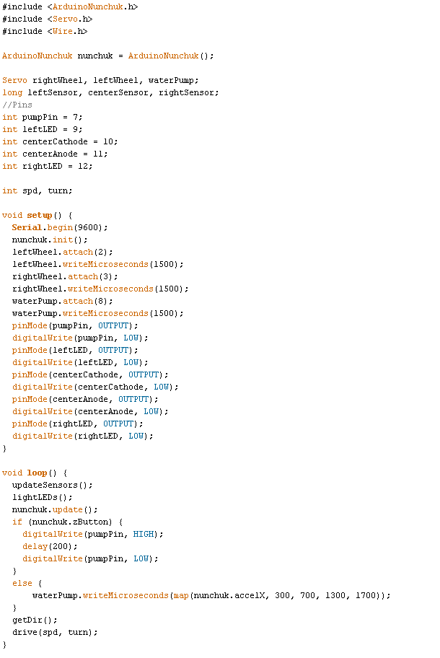
Update sensors, RCtime:
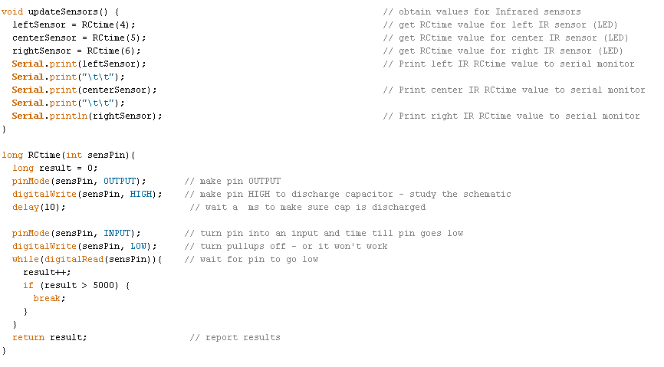
Light LED indicators
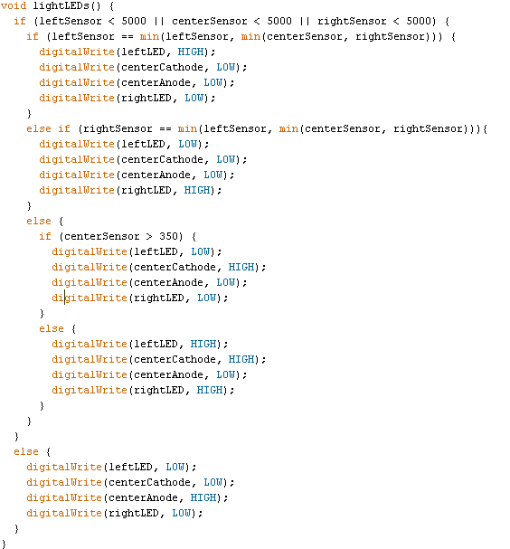
getDir() and drive
